**Homework 7 Solution**

1. Find a simultaneous solution modulo 455 to the system of congruences

$x≡1 (mod 5), x≡2 (mod 7) and x≡3 (mod 13).$

If we solve the first two equations using Chinese Remainder Theorem, we find that $x=16 (mod 35)$ is a solution. Notice that 16 is also a solution to the third equation. So 16 is a solution to all three equations.

1. Prove that $a^{13}≡a (mod 2730)$ for any integer *a.*

First note that $2730=2⋅3⋅5 ⋅7⋅13.$ Then note that by Fermat’s Little Theorem (the corollary form): $a^{13}≡a (mod 13)$ 
 ;

$a^{7}≡a (mod 7)$ and $a^{6}≡1 (mod 7)$ or $a^{}≡0 (mod 7)$, and hence $a^{13}≡a (mod 7)$; Similarly: $a^{5}≡a (mod 5)$ and hence $a^{13}≡a (mod 5)$;

Similarly: $a^{3}≡a (mod 3)$ and hence $a^{13}≡a (mod 3)$;

And finally $a^{13}≡a (mod 2)$ because taking 13th power preserves parity.

Therefore, $a^{13}-a ≡0$ modulo 2, 3, 5, 7, 13, which implies $a^{13}-a ≡0$ modulo 2730 as well.

****  
Check out this stackexchange page for other ways of doing this problem (interesting ideas):  
<https://math.stackexchange.com/questions/596074/how-to-show-that-2730-mid-n13-n-forall-n-in-mathbbn>

Here’s another solution that also gives you a method for constructing your own problem with different numbers in the future in case you need a number theory homework problem and your students have Chegg (yes, the question is on Chegg as well; why? That student clearly hasn’t figured out how to search for problems on stackexchange and has too much money to throw away… and we can argue they also don’t have strong ethics, but I’m not going to judge their desperation levels):  
https://www.quora.com/How-do-I-prove-the-identity-x-13-equiv-x-mod-2730-for-any-integer-x

1. If *p*  is prime and *p* does not divide *a*, show that $a^{(p-1)/2}≡ ±1 (mod p).$

Let $b=a^{(p-1)/2}.$ By Fermat's Little Theorem we know that $b^{2}=(a^{(p-1)/2})^{2}≡a^{p-1}≡1 (mod p)$. Thus, $p | b^{2}-1=(b-1)(b+1).$ But since *p* is prime, this means $p | b-1$ or $p | b+1.$ This results in the conclusion in the statement of the problem.

1. Use Fermat’s Little Theorem to show that $(a+b)^{p}≡a^{ p}+ {b }^{p} (mod p)$ for any prime *p.* (This is sometimes referred to as the "freshman's dream"; see <https://en.wikipedia.org/wiki/Freshman%27s_dream> )

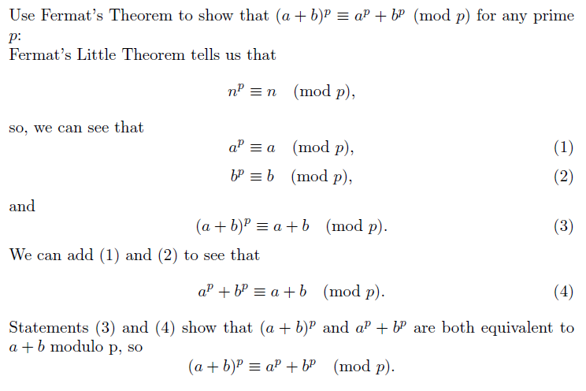

1. Find the solution of the system

$3x≡7 (mod 5), x≡1 (mod 4), 5x≡2 (mod 11).$

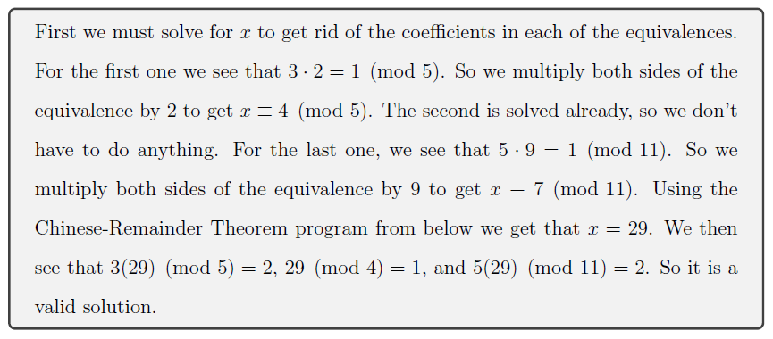

1. Find five consecutive positive integers such that the first is divisible by 2, the second is divisible by 3, the third by 5, the fourth by 7 and the fifth by 11.

* We can set up a system of congruences in terms of the first number, $x$, of the sequence. Solving this using the chinese remainder theorem yields:












$x≡0 (mod 2)$ $x≡0 (mod 2)$ $3⋅5⋅7⋅11⋅x_{1}≡0 (mod 2)$

$x+1≡0 (mod 3)$ $x≡-1 (mod 3)$ $2⋅5⋅7⋅11⋅x_{2}≡-1 (mod 3)$

$x+2≡0 (mod 5)$ $x≡-2 (mod 5)$ $2⋅3⋅7⋅11⋅x_{3}≡-2 (mod 5)$

$x+3≡0 (mod 7)$ $x≡-3 (mod 7)$ $2⋅3⋅5⋅11⋅x_{4}≡-3 (mod 7)$

$x+4≡0 (mod 11)$ $x≡-4 (mod 11)$ $2⋅3⋅5⋅7⋅x_{5}≡-4 (mod 11)$

$x_{1}≡0 (mod 2)$ $x_{1}≡0 (mod 2)$ $s_{1}=0$

$2x_{2}≡2 (mod 3)$ $x_{2}≡1 (mod 3)$ $s_{2}=1$

$2x_{3}≡-2 (mod 5)$ $x_{3}≡-1 (mod 5)$ $s_{3}=-1$

$x_{4}≡4 (mod 7)$ $x_{4}≡4 (mod 7)$ $s_{4}=4$

$x_{5}≡-4 (mod 11)$ $x_{5}≡-4 (mod 11)$ $s_{5}=-4$

$2⋅3⋅5⋅7⋅11=2310=n$

$x_{0}=\frac{n}{2}s_{1}+\frac{n}{3}s_{2}+\frac{n}{5}s_{3}+\frac{n}{7}s_{4}+\frac{n}{11}s_{5}=0+770-462+1320-840≡788 (mod n)$

* Thus, a sequence satisfying the conditions is 788, 789, 790, 791, 792

1. Write a code to implement the Chinese remainder theorem. Your code should check if the conditions of the theorem apply.

